.**CSCE 5320 Scientific Data Visualization.   
ICE-3**

Interactions.

# **Create and use the data calculated fields.**

1． Firstly, we load the database table and create a new worksheet. We open the calculate field editor by clicking on the downward arrow in the Data Tab on the left and then clicking the “Create calculated Field” option from the drop down.  
2． Then we create Calculated Filed “Cost” which is calculated by subtracting Profit column values from Sales column values. We also create the “Profit %” field by dividing profit by cost and multiplying with 100.

3． We shall be using the Profit %, Segment, and Category fields and create a horizontal bar chart as shown below. Here the profit is added to the columns tab, Category and Segment are added to the Rows tab and Category is also added to Color Marks.

From the above figure we can observe that each Categories Furniture, Office Supplies, Technology is further divided into 3 segments Consumer, Corporate and Home Office. We have each category color coded, blue indicates that the category is Furniture, orange indicates Office supplies and Red indicates Technology. We can also observe the profits on the different categories with respect to the segments. For example, the profit on Furniture’s for corporate segment is around 10k.

# Interactivity with text and visual tooltips

4． Now we add Sales, Cost and Quantity fields to the Tooltip to interactively observe these fields for each segment in the Categories. We analyze Consumer and Home Office segments from the Technology Category. From below figure, we can observe that the Cost is 384,058, Profit % is 15,510, Quantity of items is 4,166 and Sales is 391,049 for the Consumer segment of furniture category.A screenshot of a computer
From below figure, we can observe that the Cost is 118,055, Profit % is 6,007, Quantity of items is 1,367 and Sales is 121,931 for the Home Office segment of furniture category.

# Interactivity with actions (filter)

5. To show the interactions between sheets, we shall be using action filters. Firstly, we create a source sheet with Quantity in rows and Category in columns. Then we create a destination sheet with Quantity in rows and Category as well as Sub-category in columns. We add region to the color marks to divide the Category and Sub-Category in Source and Destination sheet into Central (blue), East (Orange), South (Red) and West (Turquoise) Regions.

6. From the Menu Bar we select the “Worksheet” menu and select the “Actions” option from the dropdown. From the “Actions” window how click on the “Add Action” dropdown and select “Filter” option.

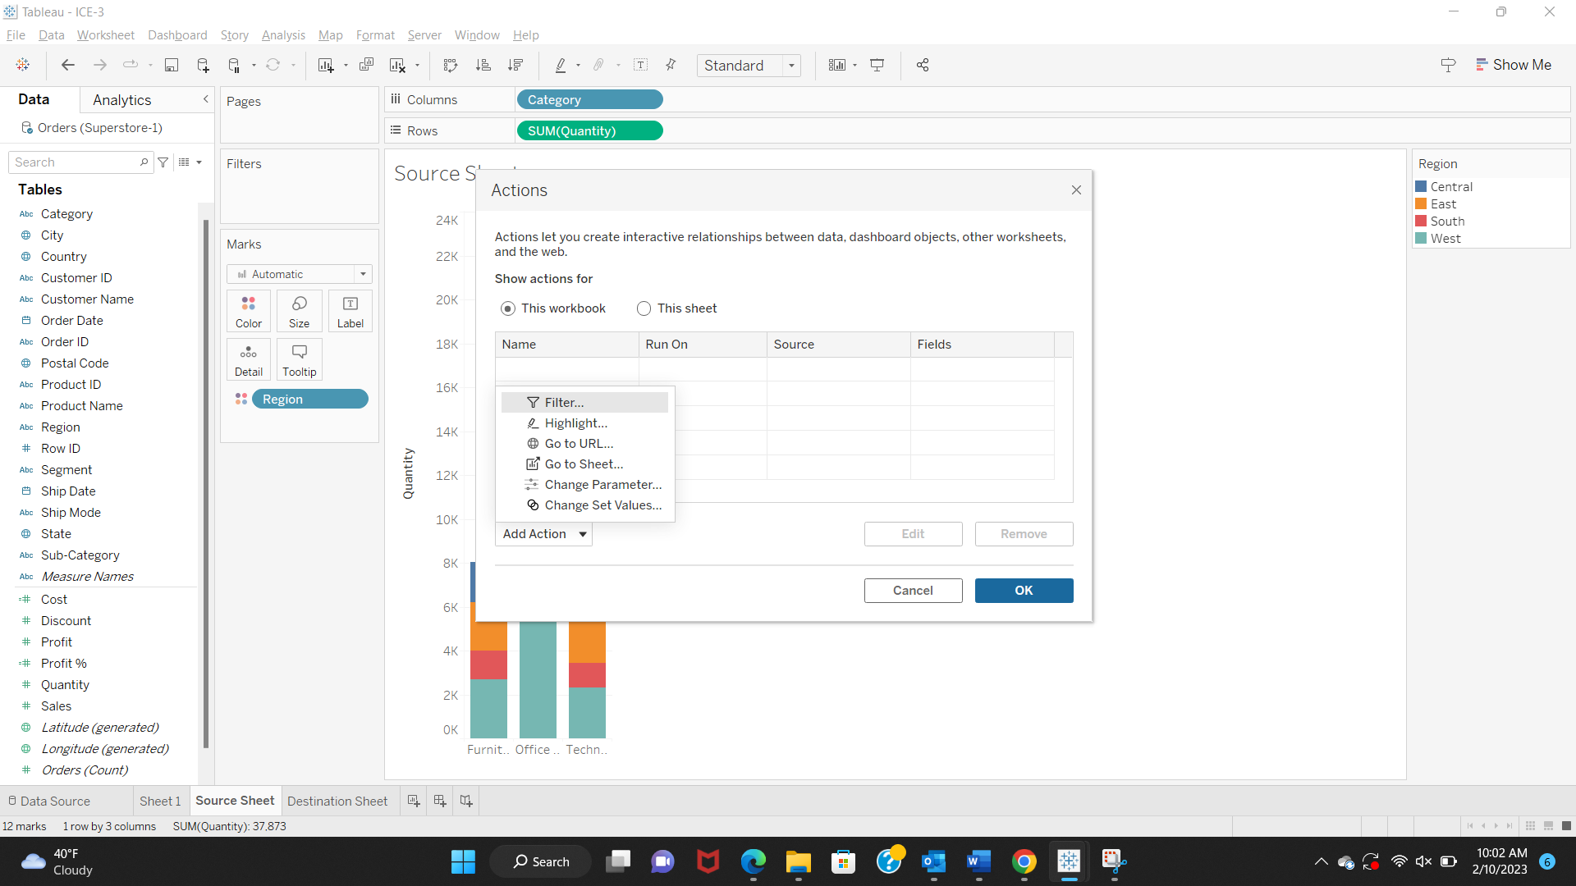

We select the Source and Target sheets i.e., the new source sheet and destination sheet that we have created. We select all options as shown below and click Ok button to confirm all changes.

7. In the source sheet, we select furniture and technology categories of West region.

We can now see the selected categories and regions in the destination sheet.

Similarly in the source sheet, I have selected the Furniture and Office Supplies categories from the regions West and South as shown below. It shows in the destination sheet as well.

# **Interactivity with actions – highlight**

8. Now using the same source and destination sheet, we apply Category to color marks. Now we create a new action, From the “Actions” window how click on the “Add Action” dropdown and select “Highlight” option. Select options as shown below.

If we select the category, the highlighted category is highlighted in the destination sheet as well. I have highlighted the Office Supplies category in the source sheet.

The destination sheet also shoes the highlighted Office Supplies section, showing the Quantity of each sub-category in the selected category.

9. Now a new dashboard is created, source sheet and destination sheet are added to the dashboard. From the Menu Bar we select the “Dashboard” menu and select the “Actions” option from the dropdown. From the “Actions” window, click on the “Add Action” dropdown and select “Highlight” option. Select all the options as shown below.

Now, we can analyze various categories, if we select Furniture category from the source sheet on dashboard 1, we can see that the Furniture category is highlighted on the destination sheet as well.

Similarly, I have selected the Office Supplies section as shown below, the highlighted category on source section reflects the changes on the destination sheet.

We can also select multiple categories together, I have selected Furniture and Technology categories.

# **Interactivity with actions – URL**

10．Now we create a new worksheet as city sales, I have created the map-based visualization by adding Longitude to columns, Latitude to rows, added city to color marks, and States, Quantity and Sales are added to tooltip. As shown below, map is created with cities color coded and shows the state, quantity and sales of each city selected.

Now, we add a new action “Add URL Action” as shown below for the city sales worksheet.

Whenever we click on any city on the map, a Wikipedia page of that city opens. Now I have selected Arlington city, it shows the State, Quantity, and Sales. The Wikipedia page for Arlington city is opened on the web browser.

